06/12/1991
xxx-xx-4652

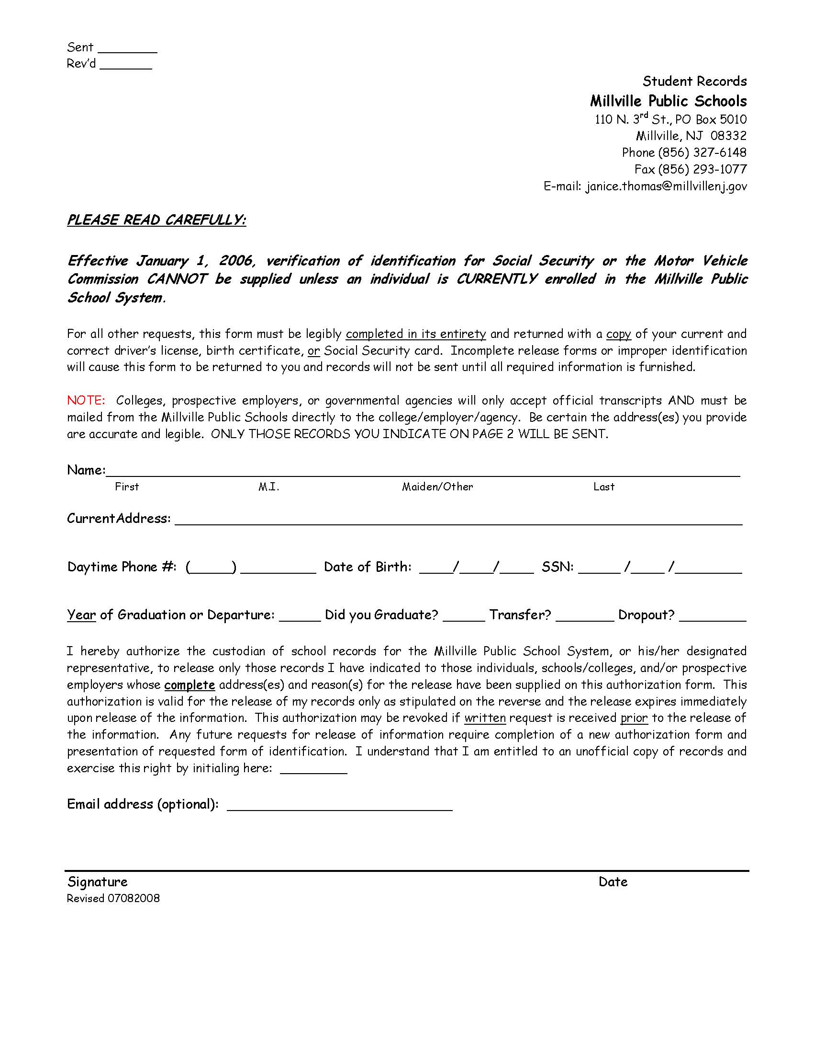
D'Atra Jones
5816 Doris DriveMillvilleNJ
06/12/1991
xxx-xx-4652
Order No.: 01-19315-003
Axiom Requisition Copy Service, 447 N. Canal Road, Lansing, MI 48917

X
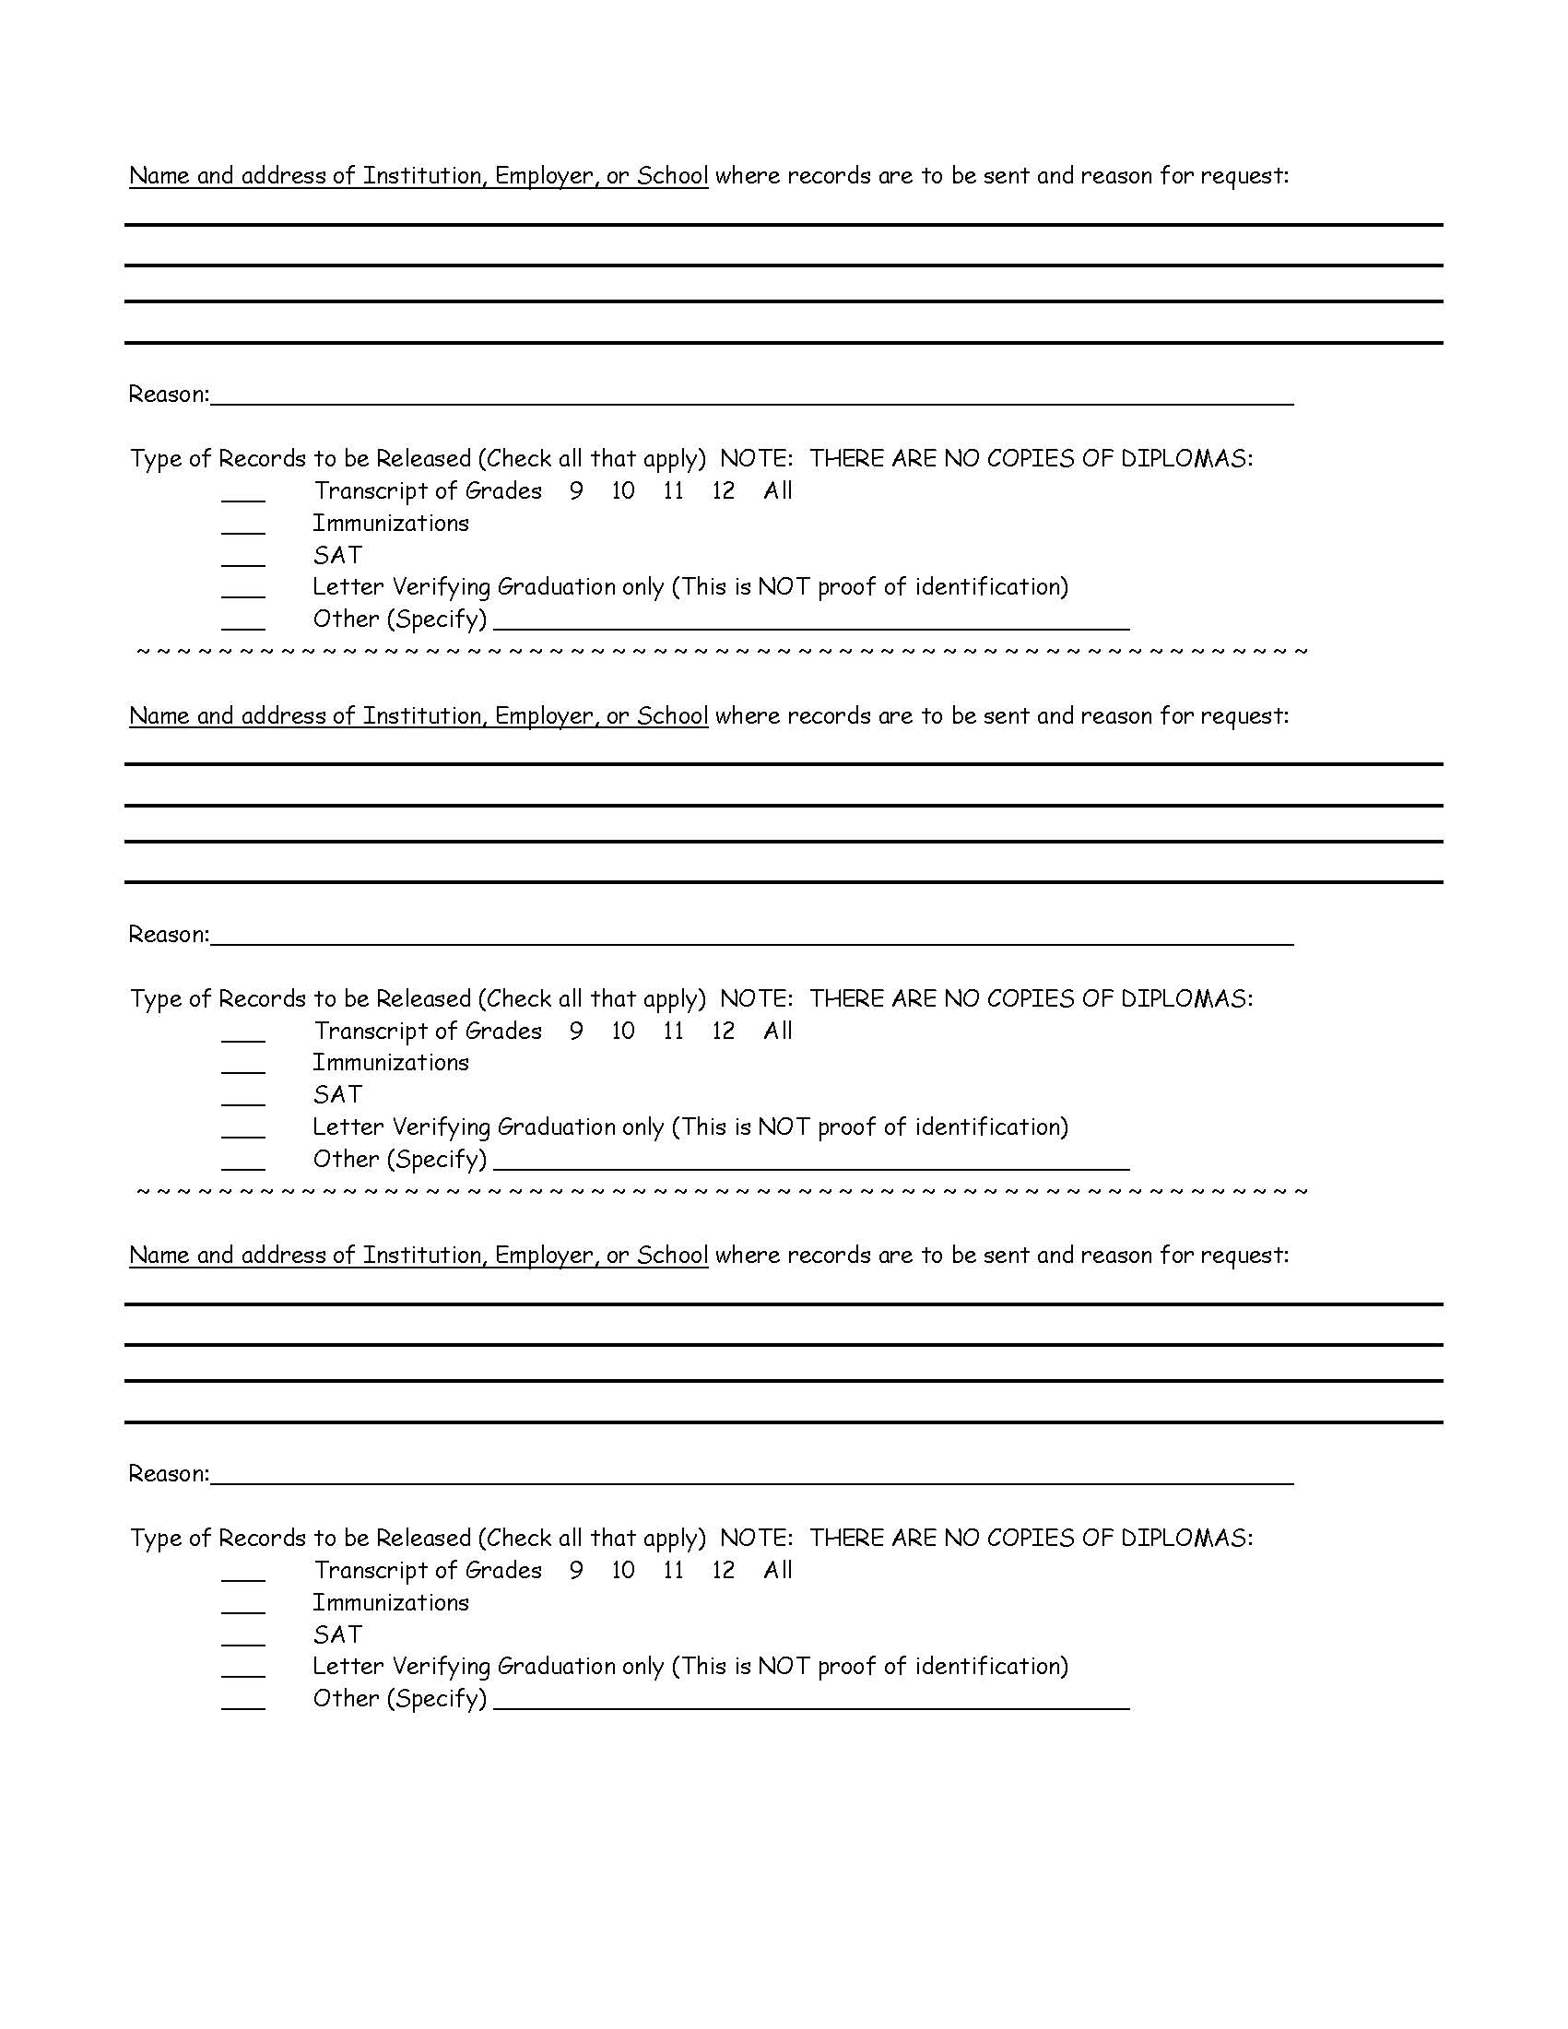
Legal Discovery
X
Axiom Requisition Copy Service, 447 North Canal Road, Lansing, MI 48917
Any and all Educational/School records generated from 06/12/1991 to present pertaining to D'Atra Jones SSN: xxx-xx-4652, DOB: 06/12/1991.
Order No.: 01-19315-003

